**Functional Requirement Document for Social Media Application – Echo**

   
 

**Contents:**

1. Introduction 3
2. Purpose 3
3. Intended Audience 3
4. Functional Requirements 3
5. Login Page 3
6. Registration Page 4
7. Home Page 5
8. Search Feature 7
9. Suggestions Box                                                                            8
10. Explore Box 10
11. Notifications Box 11
12. Followers/Following Box 12
13. Profile Page 13

2.9.1 Update Profile Box 15

**1. Introduction:**

Echo is an innovative social media application designed to bring people closer through seamless interaction and discovery. It offers a streamlined, user-centric platform. We aim to eliminate digital friction, enabling users to effortlessly share their voice, deepen connections, and engage in a vibrant community, free from unnecessary distractions.

**1.1 Purpose:**

Echo's purpose is to provide a platform for users to express themselves, share ideas, and connect with others in real-time. It’s designed to foster engaging conversations, explore trending topics, and create a sense of community through features like hashtags, messaging, and posts.

**1.2 Intended Audience:**

* Development Team
* QA Team
* Business Analyst
* DB Team

**2. Functional Requirements:**

* When the user types the URL, <http://www.echo1234.com/>  it should navigate to the Login Page.

1. **Login Page:**

The Login page contains the following fields and features:

* Username input field.
* Password input field.
* A "Login" button for user authentication.
* A "New to Echo? Register" button that redirects to the registration page.

Visual elements include a split design with a title("Echo Awaits.") and a welcome message ("Sign in to connect with your world. Your feed, your friends, and your thoughts are ready for you.") on the left, set against a themed background image of people looking upwards. The right side contains the login form with a "Login" heading.

(Login page screen is shown in Figure **2.1)**

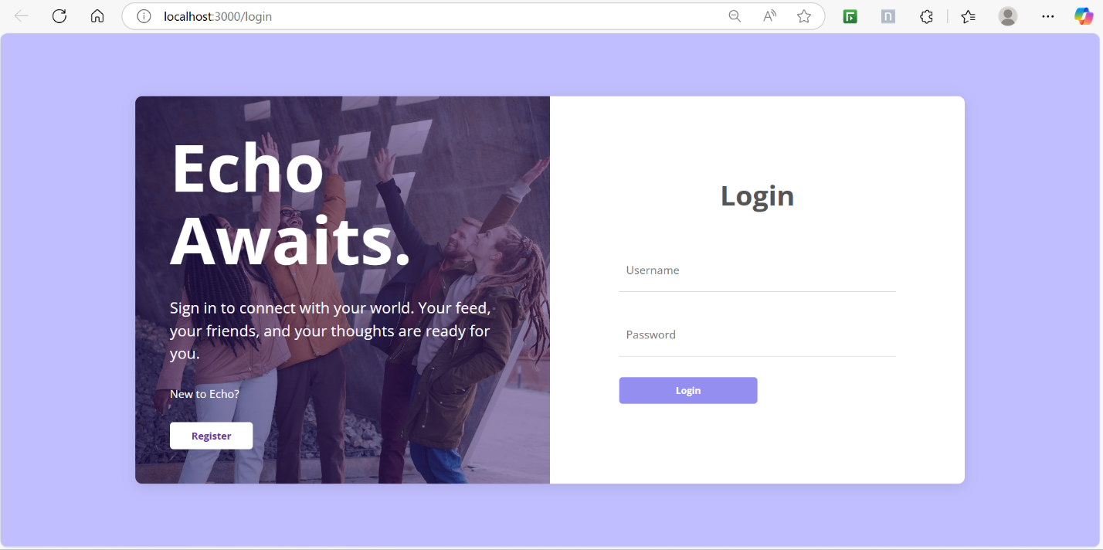

Figure 2.1

**2.2 Registration Page:**

The Registration page contains the following fields and features:

* Username input field.
* Email input field.
* Password input field.
* Name input field.
* A "Register" button for user account creation.
* An "Already have an account? Login" button that redirects to the login page.

Visual elements include a split design with a "Register" heading and the registration form on the left. The right side displays a "Echo" title and a descriptive welcome message ("Connect, share, and discover on Echo. Join our vibrant community to express your thoughts, amplify your connections, and explore what truly resonates with you."), set against a themed background image of people looking down at the camera.

(Registration page screen is shown in Figure **2.2)**

, Picture

Figure 2.2

**2.3 Home Page:**

The Home page features the following sections and functionalities:

**Left Sidebar:**

* User's profile picture and username (_mathur.02).
* Navigation links:
* Home
* Explore
* Notifications
* Messages
* Friends

**Top Bar:**

* "Echo" logo/text.
* A search bar with placeholder "Search by username or name...".
* Icons for profile, messages, settings, and "Logout".
* A toggle button (currently showing a sun icon, suggesting light/dark mode switch).

**Main Content Area (from top to bottom):**

* **Story/Featured Content Section:** Displays user stories or featured posts from other users with images and names (e.g., "Eveline Baker", "Jesse George", "Turner Kali", "Marie Rose").
* **New Post/Status Update Section:**
* User's profile picture.
* A text input field with placeholder "What's on your mind jann?".
* Buttons to "Add Image", "Add Place", "Tag Friends".
* A "Share" button.
* **Feed/Timeline Section:** Displays individual posts, each including:
* User's profile picture and name (e.g., "Jack Randall").
* Timestamp (e.g., "a few seconds ago").
* Post content (e.g., "Lorem ipsum dolor sit amet consectetur adipiscing elit.").
* An image associated with the post.

**Right Sidebar:**

* **Suggestions For You:**
* Lists user suggestions with profile pictures, names (e.g., "Kamalesh", "Aviral", "Priyanshu kumar jha").
* "Follow" button for each suggestion.
* "Dismiss" button for each suggestion.
* **Explore Trending Topics:**
* A list of trending topics presented as hashtags (e.g., "#Advancements", "#FutureTech", "#GlobalEconomy", "#ClimateAction", "#SpaceExploration", "#HealthInnovation", "#SustainableLiving", "#GamingWorld", "#DigitalArt", "#NewMusic", "#StartupLife", "#CyberSecurity").
* **Notifications Section:**
* A heading "Notifications".
* Placeholder text: "Your notifications will be displayed here."

(Home page screen is shown in Figure **2.3)**

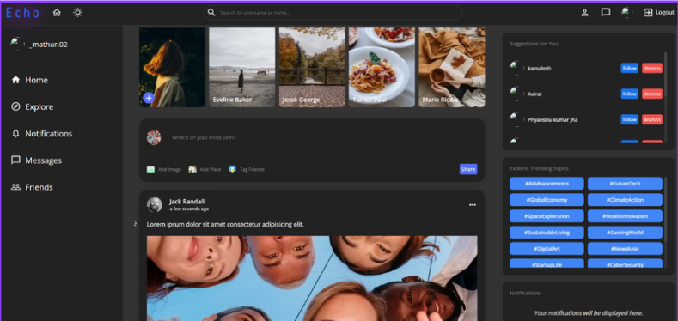

Figure 2.3

**2.4 Search Feature:**

* Location: Prominently positioned in the center of the top navigation bar.
* Input Field: Features a text input area with a magnifying glass icon on the left, suggesting its search function.
* Placeholder Text: (Implied, as text is currently entered) The initial placeholder would likely be "Search by username or name..." as seen in the previous image, guiding the user on what to search for.
* Dynamic Suggestions: As the user types (e.g., "Av" is typed in the image), a dropdown list of relevant suggestions appears directly below the search bar.
* Suggestion Content: The suggestions include:
* Usernames/Names: For example, "Aviral Mathur", "Akshat Kamboj", "Prajesh", "Dhruv Raghuvanshi", "Yatharth".
* Profile Pictures: Each suggestion is accompanied by a small profile picture (or a placeholder icon if no picture is available), aiding in user identification.
* Scrollable List: The dropdown list appears to be scrollable, indicated by the scrollbar on the right, suggesting it can accommodate numerous search results.
* User Interaction: Users can likely click on a suggestion to navigate directly to that user's profile or related content.

(Search Feature is shown in Figure **2.4)**

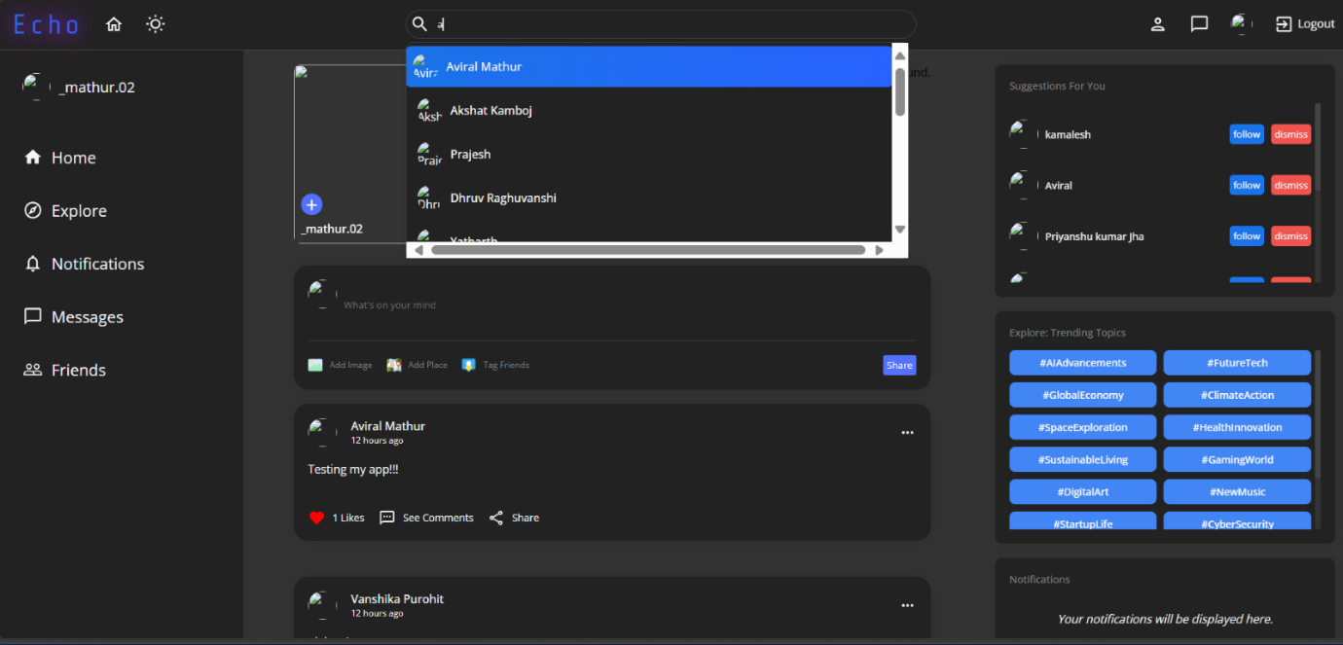

Figure 2.4

**2.5 Suggestions Box:**

* Location: Situated in the upper part of the right sidebar, above the "Explore: Trending Topics" section.
* Heading: Clearly labeled "Suggestions For You," indicating its purpose to recommend other users to the current user.
* Content: This box displays a list of individual user suggestions. Each suggestion typically includes:
* Profile Picture: A small circular image representing the suggested user's profile.
* Username/Name: The name or username of the suggested user (e.g., "Kamalesh", "Aviral", "Priyanshu kumar jha").
* "Follow" Button: A prominent blue button that allows the current user to instantly follow the suggested user.
* "Dismiss" Button: A red button that allows the current user to dismiss or hide the suggestion, indicating they are not interested in following that particular user.
* Purpose: This feature aims to help users expand their network on the "Echo" platform by suggesting other accounts they might be interested in following. This promotes user engagement and discovery within the community.
* Visual Style: Each suggestion is presented as a distinct entry, with the profile picture and name on the left, and the "Follow" and "Dismiss" actions on the right. The box itself has a dark background, consistent with the overall dark mode theme of the page.

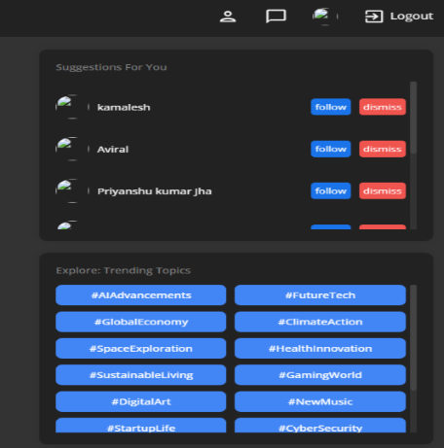(Suggestions Box is shown in Figure **2.5)**

Figure 2.5

**2.6 Explore Box:**

* Location: Situated in the right sidebar, below the "Suggestions For You" section.
* Heading: Clearly labeled "Explore: Trending Topics".
* Content: This box is dedicated to showcasing popular and currently trending subjects within the "Echo" platform.
* Format: Topics are presented as interactive "hashtag" buttons (e.g., #AIAdvancements, #FutureTech, #GlobalEconomy, #ClimateAction, #SpaceExploration, #HealthInnovation, #SustainableLiving, #GamingWorld, #DigitalArt, #NewMusic, #StartupLife, #CyberSecurity).
* Visual Style: Each trending topic is enclosed within a rectangular button with a blue background and white text, making them visually distinct and clickable.
* Purpose: This section serves as a discovery tool, allowing users to easily click on a trending topic to view related posts, discussions, or users. It helps users stay updated with popular conversations and potentially find new communities or interests.

(Explore Box is shown in Figure **2.6)**

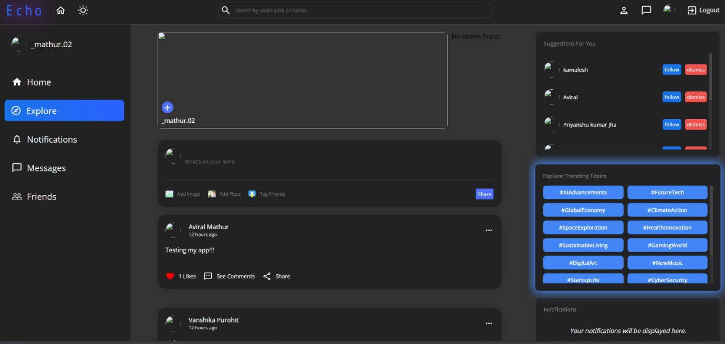  
Figure 2.6

**2.7 Notifications Box:**

* Location: Situated at the very bottom of the right sidebar, beneath the "Explore: Trending Topics" section.
* Heading: Clearly labeled with "Notifications" as its title, indicating the purpose of this section.
* Content: This box currently displays placeholder text.
* The text reads: "Your notifications will be displayed here."
* Current State: Based on the placeholder, it implies that there are no new notifications for the user at this moment, or that this area is reserved for displaying notifications when they arrive.
* Purpose: The intended function of this box is to inform the user about activities relevant to them, such as new likes, comments, mentions, friend requests, or other system alerts.

(Notifications Box is shown in Figure **2.7)**

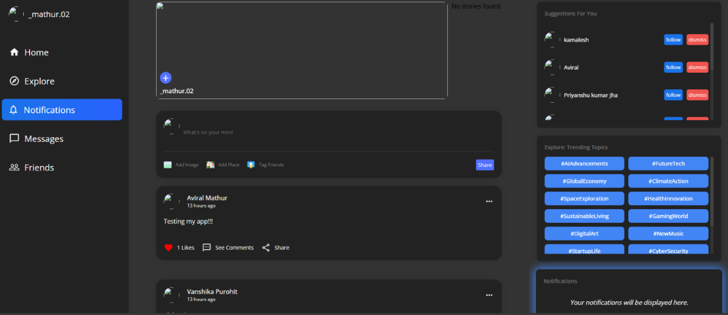

Figure 2.7

**2.8 Followers/Following Box:**

* **Modal Design:** Both appear as overlaying pop-up windows, indicating they are temporary displays on top of the main content.
* **Title:** Each box has a clear, bold title at the top, either "Following" or "Followers," indicating the type of list being displayed.
* **Close Button:** A prominent "X" icon is present in the top-right corner of both boxes, allowing the user to close the pop-up.
* **User List:** Both boxes present a list of individual users. For each user entry, the following elements are consistently displayed:
  + **Profile Placeholder/Icon:** A small, circular placeholder or icon, likely intended to be replaced by the user's actual profile picture.
  + **User Name:** The name of the user is displayed next to their profile icon.
* **Scrollable Content:** The presence of a vertical scrollbar (implied by the number of entries and typical UI design for such lists) suggests that these lists can contain more users than are immediately visible, allowing the user to scroll through all entries.
* **"Following" Box:** Lists the users that the current user is following.
* 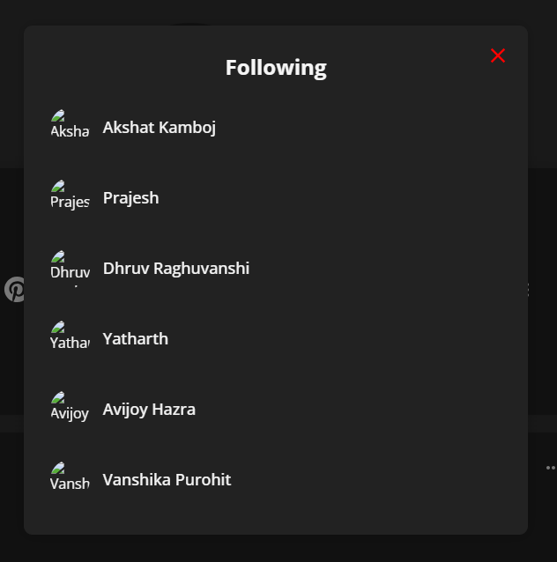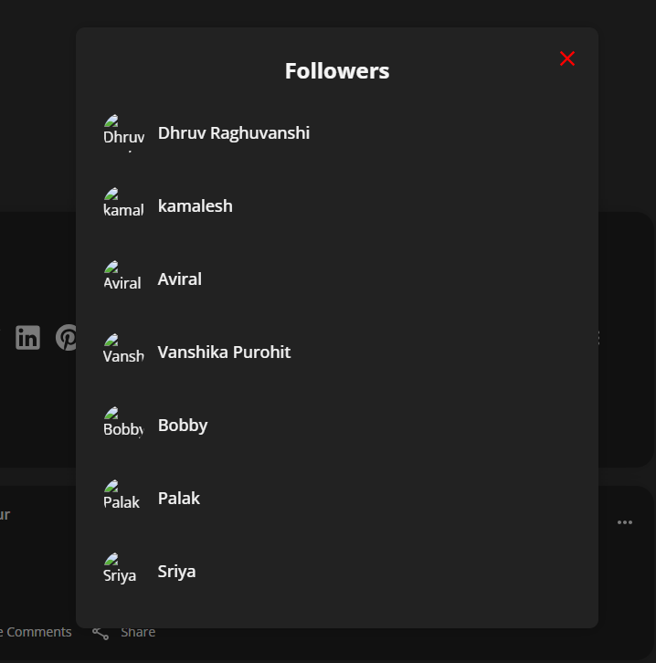**"Followers" Box:** Lists the users who are following the current user.

Figure 2.8

**2.9 Profile Page:**

* A large placeholder area at the top labeled "Cover," presumably for a cover photo.
* A circular placeholder in the middle, likely for a profile picture, overlaid on the cover area.
* A central dark-themed card containing the user's primary profile information.
* Below the profile information card, there's a section displaying the user's posts, starting with their most recent ones.

**Profile Information Card:**

* **User Name:** Displays the user's full name prominently (e.g., "Aviral Mathur").
* **Location:** Shows a geographical location (e.g., "New Delhi") accompanied by a map pin icon.
* **Website/Link:** Includes a link or identifier, possibly for a personal website or other external link (e.g., "git") accompanied by a globe icon.
* **Social Media Icons:** A row of familiar social media icons (Facebook, Instagram, Twitter, LinkedIn, Pinterest), suggesting integration or links to the user's profiles on these platforms.
* **Follower/Following Count:**
  + Clearly displays "7 Followers" and "6 Following," indicating the user's network size.
  + These are likely clickable elements that would open detailed lists of followers and following, respectively (as seen in previous descriptions).
* **Action Buttons/Icons:**
  + An "Update" button, likely for the user to edit their profile information.
  + An envelope icon, suggesting a direct message or contact option.
  + A three-dot "More options" icon, which might reveal additional actions.

**User Posts Section:**

* Displays individual posts by the user, similar in structure to the main feed.
* **Post Details:** Each post includes:
  + User's profile picture placeholder.
  + User's name (e.g., "Aviral Mathur").
  + Timestamp (e.g., "13 hours ago").
  + Post content (e.g., "Testing my app!!!").
  + Engagement metrics: "1 Likes" (with a red heart icon, indicating it's liked).
  + Interaction options: "See Comments" and "Share" links.
  + A screenshot of a computer

    AI-generated content may be incorrect.A three-dot "More options" icon for the post itself, possibly for editing or deleting.

Figure 2.9

**2.9.1 Update Profile Box:**

The "Update Your Profile" is a modal or dedicated page designed for users to modify their profile information. It is characterized by its dark mode theme and a scrollable interface.

* Title: "Update Your Profile" is prominently displayed at the top, indicating the purpose of this section.
* Two distinct sections for uploading images: "Cover Picture" and "Profile Picture."
* Each section features:
  + An upload icon (cloud with an arrow pointing up), visually cueing the upload functionality.
  + Placeholder lines, indicating where the image preview might appear once uploaded.
* Email: An input field for the user's email address (e.g., mathur.aviral02@gmail.com). This field is likely read-only or editable.
* Password: An input field for updating the password. It includes helper text "Leave blank to keep current password," indicating that it's optional to change.
* Name: An input field for the user's full name (e.g., "Aviral Mathur").
* Country / City: An input field for the user's location (e.g., "New Delhi").
* Website Name: An input field for the name associated with a website (e.g., "git").
* Website URL: An input field for the full URL of the website (e.g., https://github.com/AviralMathur02).
* "Update" Button: A prominent blue button at the bottom of the form, which, when clicked, presumably saves the changes made by the user.

(Update Profile Box is shown in Figure **2.9.1)**

Figure 2.9.1